**PSG COLLEGE OF TECHNOLOGY, COIMBATORE – 641 004**

**Department of Applied Mathematics and Computational Sciences**

**M Sc SOFTWARE SYSTEMS – Semester IV**

**20XW48 – Web Designing Lab**

**PROBLEM SHEET 2 – HTML Tables, Image and Imagemap**

* **Swetha Muralidharan (20pw35)**

**Start Date: 3.1.2022 Complete Date: 13.1.2022**

1. Design a period table of the given form

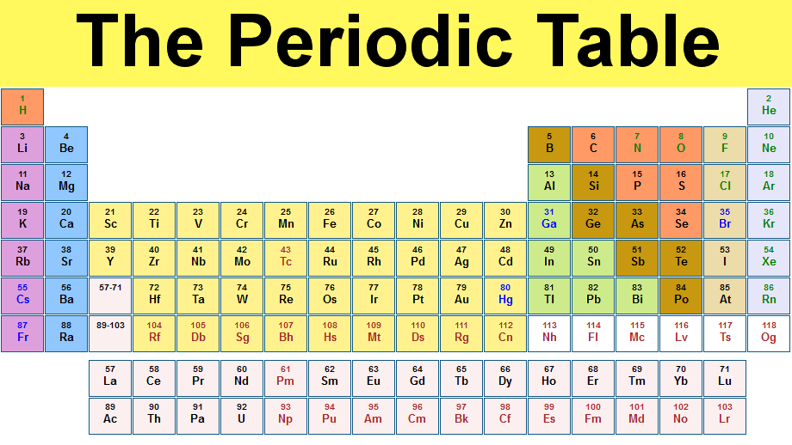

|  |
| --- |
| <html>  <head>  <title> periodic table </title>  </head>  <body>  <table width = 1000>  <tr>  <th colspan="18" bgcolor="yellow"><b> <font face="Arial Black" size="18"> The Periodic Table </font> </b> </th>  </tr>  <tr>  <td bgcolor="coral"> 1<br>H</td>  <th colspan="16"> </th>  <td bgcolor="aliceblue"> 2 <br> He </td>  </tr>  <tr>  <td bgcolor="violet">3<br> Li</td>  <td bgcolor="lightskyblue">4 <br> Be</td>  <td colspan='10'></td>  <td bgcolor="GoldenRod">5 <br> B</td>  <td bgcolor="coral">6 <br>C</td>  <td bgcolor="coral">7 <br> N</td>  <td bgcolor="coral">8 <br> O</td>  <td bgcolor="antiquewhite">9 <br> F</td>  <td bgcolor="aliceblue">10 <br> Ne</td>  </tr>  <tr>  <td bgcolor="violet">11 <br> Na</td>  <td bgcolor="lightskyblue">12 <br> Mg</td>  <td colspan='10'></td>  <td bgcolor="lightgreen">13<br> Al</td>  <td bgcolor="GoldenRod">14 <br> Si</td>  <td bgcolor="coral">15<br> P</td>  <td bgcolor="coral">16 <br> S</td>  <td bgcolor="antiquewhite">17 <br> Ci</td>  <td bgcolor="aliceblue">18 <br> Ar</td>  </tr>  <tr>  <td bgcolor="violet">19 <br> K</td>  <td bgcolor="lightskyblue">20 <br> Ca</td>  <td bgcolor="gold">21 <br> Sc</td>  <td bgcolor="gold">22 <br> Ti</td>  <td bgcolor="gold">23 <br> V</td>  <td bgcolor="gold">24 <br> Cr</td>  <td bgcolor="gold">25 <br> Mn</td>  <td bgcolor="gold">26 <br> Fe</td>  <td bgcolor="gold">27 <br> Co</td>  <td bgcolor="gold">28 <br> Ni</td>  <td bgcolor="gold">29 <br> Cu</td>  <td bgcolor="gold">30 <br> Zn</td>  <td bgcolor="lightgreen"><font color="blue">31 <br>Ga</font></td>  <td bgcolor="GoldenRod">32<br>Ge</td>  <td bgcolor="GoldenRod">33 <br>As</td>  <td bgcolor="coral">34 <br>Se</td>  <td bgcolor="antiquewhite"><font color="blue">35 <br>Br</font></td>  <td bgcolor="aliceblue">36 <br>Kr</td>  </tr>  <tr>  <td bgcolor="violet">37<br>Rb</td>  <td bgcolor="lightskyblue">38<br>Sr</td>  <td bgcolor="gold">39<br>Y</td>  <td bgcolor="gold">40 <br> Zr</td>  <td bgcolor="gold">41 <br> Nb</td>  <td bgcolor="gold">42 <br> Mo</td>  <td bgcolor="gold"><font color= "red" > 43 <br> Tc </font></td>  <td bgcolor="gold">44 <br> Ru</td>  <td bgcolor="gold">45 <br> Rh</td>  <td bgcolor="gold">46<br> Pd</td>  <td bgcolor="gold">47 <br> Ag</td>  <td bgcolor="gold">48<br>Cd</td>  <td bgcolor="lightgreen">49<br>In</td>  <td bgcolor="lightgreen">50<br>Sn</td>  <td bgcolor="GoldenRod">51<br>Sb</td>  <td bgcolor="GoldenRod">52<br>Te</td>  <td bgcolor="antiquewhite">53<br>I</td>  <td bgcolor="aliceblue">54<br>Xe</td>  </tr>  <tr>  <td bgcolor="violet"><font color="blue">55<br>Cs</font></td>  <td bgcolor="lightskyblue">56<br>Ba</td>  <td bgcolor="lavenderblush">57-71<br> </td>  <td bgcolor="gold">72 <br>Hf</td>  <td bgcolor="gold">73 <br>Ta</td>  <td bgcolor="gold">74 <br>W</td>  <td bgcolor="gold">75 <br>Re</td>  <td bgcolor="gold">76 <br>Os</td>  <td bgcolor="gold">77 <br>Ir</td>  <td bgcolor="gold">78<br> Pt</td>  <td bgcolor="gold">79 <br>Au</td>  <td bgcolor="gold">80<br>Hg</td>  <td bgcolor="lightgreen">81<br>Ti</td>  <td bgcolor="lightgreen">82<br>Pg</td>  <td bgcolor="lightgreen">83<br>Bi</td>  <td bgcolor="GoldenRod">84<br>Po</td>  <td bgcolor="antiquewhite">85<br>At</td>  <td bgcolor="aliceblue">86<br>Rn</td>  </tr>  <tr>  <td bgcolor="violet"><font color="blue">87<br>Fr</font></td>  <td bgcolor="lightskyblue">88<br>Ra</td>  <td bgcolor="lavenderblush">89-103<br> </td>  <td bgcolor="gold"><font color="red">104 <br>Rf</font></td>  <td bgcolor="gold"><font color="red">105 <br>Db</font></td>  <td bgcolor="gold"><font color="red">106<br>Sg</font></td>  <td bgcolor="gold"><font color="red">107 <br>Bh</font></td>  <td bgcolor="gold"><font color="red">108 <br>Hs</font></td>  <td bgcolor="gold"><font color="red">109 <br>Mt</font></td>  <td bgcolor="gold"><font color="red">110<br> Ds</font></td>  <td bgcolor="gold"><font color="red">111<br>Rg</font></td>  <td bgcolor="gold"><font color="red">112<br>Cn</font></td>  <td bgcolor="white"><font color="red">113<br>Nh</font></td>  <td bgcolor="white"><font color="red">114<br>Fl</font></td>  <td bgcolor="white"><font color="red">115<br>Mc</font></td>  <td bgcolor="white"><font color="red">116<br>Lv</font></td>  <td bgcolor="white"><font color="red">117<br>Ts</font></td>  <td bgcolor="white"><font color="red">118<br>Og</font></td>  </tr>  <tr>  <td colspan="2"> </td>  <td bgcolor="lavenderblush"> 57 <br> La </td>  <td bgcolor="lavenderblush"> 58 <br> Ce </td>  <td bgcolor="lavenderblush"> 59 <br> Pr </td>  <td bgcolor="lavenderblush"> 60 <br> Nd </td>  <td bgcolor="lavenderblush"><font color="red"> 61 <br> Pm </font></td>  <td bgcolor="lavenderblush"> 62 <br> Sm </td>  <td bgcolor="lavenderblush"> 63 <br> Eu </td>  <td bgcolor="lavenderblush"> 64 <br> Gd </td>  <td bgcolor="lavenderblush"> 65 <br> Tb </td>  <td bgcolor="lavenderblush"> 66 <br> Dy </td>  <td bgcolor="lavenderblush"> 67 <br> Ho </td>  <td bgcolor="lavenderblush"> 68 <br> Er </td>  <td bgcolor="lavenderblush"> 69 <br> Tm </td>  <td bgcolor="lavenderblush"> 70 <br> Yb </td>  <td bgcolor="lavenderblush"> 71 <br> Lu </td>  <td colspan="1"> </td>  </tr>  <tr>  <td colspan="2"> </td>  <td bgcolor="lavenderblush"> 89 <br> Ac</td>  <td bgcolor="lavenderblush">90 <br> Th </td>  <td bgcolor="lavenderblush">91 <br> Pa </td>  <td bgcolor="lavenderblush">92 <br> U</td>  <td bgcolor="lavenderblush"><font color="red"> 93 <br> Np </font></td>  <td bgcolor="lavenderblush"><font color="red"> 94 <br> Pu </font></td>  <td bgcolor="lavenderblush"><font color="red"> 95 <br> Am </font></td>  <td bgcolor="lavenderblush"> <font color="red">96 <br> Cm </font></td>  <td bgcolor="lavenderblush"><font color="red"> 97 <br> Bk </font></td>  <td bgcolor="lavenderblush"><font color="red"> 98 <br> Cf </font></td>  <td bgcolor="lavenderblush"> <font color="red">99 <br> Es </font></td>  <td bgcolor="lavenderblush"> <font color="red">100 <br> Fm</font></td>  <td bgcolor="lavenderblush"> <font color="red">101 <br> Md </font></td>  <td bgcolor="lavenderblush"> <font color="red">102 <br> No </font></td>  <td bgcolor="lavenderblush"><font color="red"> 103 <br> Lr </font></td>  <td colspan="1"> </td>  </tr>    </p>  </table> |

|  |
| --- |
|  |

1. Design a table as given below. One image is align a left side and other image is in right sideas zigzap format. (Note: Instead of 1,2,3… you add any image and give description about an image)

(image type is animal/fruits/National leaders etc.,)



|  |
| --- |
| <html>  <body>  <h1 align="center"> <font color="red" size="72" face="Bradley Hand ITC" > <b> MISSING PET? </b> </font></h1>  <br>  <br>  <h2>1 . Notify neighbours and friends</h2>  <h2><img src="https://th.bing.com/th/id/OIP.D96AN2oIpsDSm7JaaX0RfgHaHg?w=194&h=196&c=7&r=0&o=5&dpr=1.25&pid=1.7"  align="left" width="150" height="150">  <br>  <br>  <br>  <h2 align="right">2 . File a lost report </h2>  <h2 align="right"><img src="https://th.bing.com/th/id/OIP.NMiIoJwuGLpL-HXBBYIbnAHaDS?w=334&h=155&c=7&r=0&o=5&dpr=1.25&pid=1.7" align="right" width="150" height="150">  <br>  <br>  <br>  <h2>3 . Check vet clinics </h2>  <h2><img src="https://th.bing.com/th/id/OIP.L4iBPJhIK8SMVgPWv1lnRAHaGq?w=200&h=180&c=7&r=0&o=5&dpr=1.25&pid=1.7" align="left" width="150" height="150">  <br>  <br>  <br>  <h2 align="right">4 .Microchipped? </h2>  <h2 align="right"><img src=" https://th.bing.com/th/id/OIP.QUsJQf7_DsaRLAHUwy1XjQHaHa?w=194&h=194&c=7&r=0&o=5&dpr=1.25&pid=1.7" align="right" width="150" height="150">  <br>  <br>  <br>  <h2>5 . Social media </h2>  <h2><img src="https://th.bing.com/th/id/OIP.idOAjCbfSA7cdZw3UN-AzwHaJX?w=140&h=180&c=7&r=0&o=5&dpr=1.25&pid=1.7" align="left" width="150" height="150">  <br>  <br>  <br>  <h2 align="right">6 .Go and look </h2>  <h2 align="right"><img src="https://th.bing.com/th/id/OIP.CAhwtNrDglg0lGcc4Cj_TQHaHR?w=208&h=204&c=7&r=0&o=5&dpr=1.25&pid=1.7" align="right" width="150" height="150">  <br>  </body>  </html> |
|  |
|  |

1. Design a table in the given way.

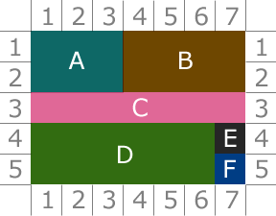

|  |
| --- |
| <html>  <body>  <table border="2" align ="center" width="500" height="300">  <td> </td>  <td><p align="center"> 1 </p> </td>  <td> <p align="center">2</p> </td>  <td> <p align="center"> 3 </p> </td>  <td><p align="center"> 4</p> </td>  <td><p align="center"> 5 </p> </td>  <td> <p align="center">6 </p> </td>  <td> <p align="center">7 </p></td>  <td> </td>  </tr>  <tr>  <td> <p align="center">1</p></td>  <td rowspan = "2" colspan = "3" bgcolor="cadetBlue" > <font color="white"> <p align="center">A </p> </font></td>  <td rowspan = "2" colspan = "4" bgcolor="saddleBrown" > <font color="white"> <p align="center">B</p> </font> </td>  <td> <p align="center"> 1</p> </td>  <tr>  <td> <p align="center"> 2 </p> </td>  <td> <p align="center"> 2</p></td>  </tr>  <tr>  <td> <p align="center"> 3 </p></td>  <td rowspan="1" colspan="7" bgcolor="Hotpink"> <font color="white"><p align="center"> C </p> </font></td>  <td> <p align="center"> 3 </p> </td>  </tr>  <tr>  <td> <p align="center"> 4 </p> </td>  <td rowspan="2" colspan="6"bgcolor="green"><font color="white"> <p align="center"> D </p> </font></td>  <td bgcolor="midnightblue"> <font color="white"> <p align="center"> E </p> </font> </td>  <td> <p align="center"> 4 </p> </td>  </tr>  <tr>  <td><p align="center"> 5 </p></td>  <td bgcolor="darkblue" > <font color="white"> <p align="center">F </p> </font></td>  <td> <p align="center">5 </p></td>  </tr>  <tr>  <td> </td>  <td> <p align="center"> 1 </p></td>  <td> <p align="center">2 </p></td>  <td> <p align="center">3 </p></td>  <td> <p align="center">4 </p></td>  <td><p align="center"> 5</p> </td>  <td><p align="center"> 6 </p></td>  <td> <p align="center">7 </p></td>  <td> </td>  </tr>  </body>  </html> |
|  |

1. Design a table of ypur own with a background image. A sample is given for the reference.

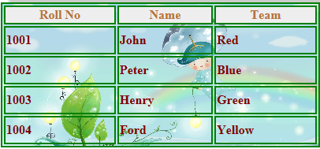

|  |
| --- |
| <html>  <body>  <table border="3" background="E:\SEM4\Web designing lab\WS2\img.jpg" width="400" height="200" cellspacing="5" >  <tr bgcolor="white">  <th> <font color="orange"> Roll No </font></th>  <th> <font color="orange">Name </font></th>  <th> <font color="orange">Team </font></th>  </tr>  <tr>  <td><font color="brown">1001</font></td>  <td><font color="brown">John</font></td>  <td><font color="brown">Red </font></td>  </tr>  <tr>  <td><font color="brown">1002</font></td>  <td><font color="brown">Peter</font></td>  <td><font color="brown">Blue</font></td>  </tr>  <tr>  <td><font color="brown">1003</font></td>  <td><font color="brown">Henry</font></td>  <td><font color="brown">Green </font> </td>  </tr>  <tr>  <td><font color="brown">1004</font></td>  <td><font color="brown">Ford</font></td>  <td><font color="brown">Yellow </font></td>  </tr>  </table>  </body>  </html> |
|  |

1. Design a page of the following design.

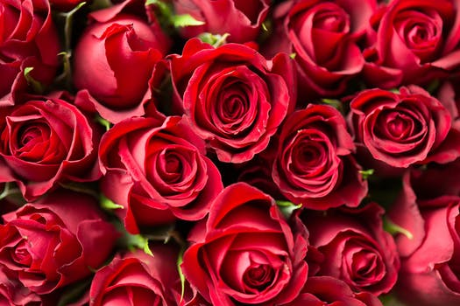

**Rose Flower** is a perennial plant the genus rosa, within the family roses. Roses are a popular crop for both domestic and commercial cut flowers. Generally they are harvested and cut when in bud, and held in refrigerated conditions until ready for display at their point of sale. In temperate climates, cut roses are often grown in greenhouses, and in warmer countries they may also be grown under cover in order to ensure that the **flowers** are not damaged by ~~weather~~ and that pests and disease control can be carried out effectively. There are many model project is on production of roses for use as cut flowers, which have an important place in *preparation* of bouquets, floral arrangements, worship, social occasions and presentation of gifts

|  |
| --- |
| <html>  <body bgcolor= "lightpink">  <h1 align="center"> <font face="arialblack" color="red" size="30" > <u> <i> RED FLOWER </i> </u> </font> </h1>  <p align="center"><img src=" red_flower.png"></p>  <pre>  <p align="center"> <font face ="Times New Roman " size="4" >  <b>Rose Flower</b> is a <u> <i> perennial plant </i> </u> the <u> genus rosa </u>, within the family  roses. Roses are a popular crop for both <u>domestic and commercial cut</u>  flowers. Generally they are harvested and cut when in bud, and held in  refrigerated conditions until ready for display at their point of sale. In  temperate climates, cut roses are often grown in greenhouses, and in  warmer countries they may also be grown under cover in order to ensure  that the <b>flowers</b> are not damaged by <strike>weather</strike> and that pests and  disease control can be carried out effectively. There are many model  project is on production of roses for use as cut flowers, which have an  important place in preparation of bouquets, floral arrangements, worship,  social occasions and presentation of gifts </font>  </p>  </pre>  </body>  </html> |
|  |

1. **Image and Text**

The red chilipepperchilipepper is a popular food product in New Mexico.  What creates the heat in this pepper is the chemical *capsaicin* (C18H27NO3).  When eaten, natural endorphins in the body are released which not only reduce the pain from the heat but create a feeling of general well-being.

|  |
| --- |
| <html>  <body bgcolor="lavender">  <pre>  <font face=" Times New Roman " size="4">  The red chilipepper <img src="https://encrypted-tbn0.gstatic.com/images?q=tbn:ANd9GcS81TafpuQZ90Zo5CtPlnMHvgwKVf26rCrnKw&usqp=CAU" width="25" height="25"> is a popular food product in New Mexico. What creates  the heat in this pepper is the chemical capsaicin (C<sub>18</sub>H<sub>27</sub>NO<sub>3</sub>). When eaten, natural  endorphins in the body are released which not only reduce the pain from the heat  but create a feeling of general well-being. </font>    </pre>  </body>  </html> |
|  |

1. **Image and align text**

|  |  |
| --- | --- |
| **The Indian Flag** | |
| http://indianflag.facts.co/Indian_Flag_CC30_Pogaface.png | The National flag of India hasthreeequal horizontal bands - the top panel is India saffron (Kesari), the bottom panel is India green and white middle band bearing at its centre the design of Ashoka Chakra in navy blue colour with 24 equally spaced spokes. It was adopted by the Constituent Assembly on 22nd July 1947, when it became the official flag of the Dominion of India. The flag was subsequently retained as that of the Republic of India. The flag is based on the Swaraj flag, a flag of the Indian National Congress designed by PingaliVenkayya. |

|  |
| --- |
| <html>  <body>  <table border="1" width="550">  <tr>  <td colspan="2" align="center"><b>The Indian Flag</b></td></tr>  <tr>  <td>  <pre><img src="indian_flag.png" width="300" height="500"></pre>  </td>  <td>  <pre>  <font face=" Times New Roman " size="5">  The National flag of India  hasthreeequal horizontal bands - the  top panel is India saffron (Kesari),  the bottom panel is India green and  white middle band bearing at its  centre the design of Ashoka Chakra  in navy blue colour with 24 equally  spaced spokes. It was adopted by the  Constituent Assembly on 22nd July  1947, when it became the official  flag of the Dominion of India. The  flag was subsequently retained as that  of the Republic of India. The flag is  based on the Swaraj flag, a flag of the  Indian National Congress designed  by PingaliVenkayya.  </pre>  </td>  </tr>  </table>  </body>  </html> |
|  |

1. Create a Html page which depicts the lifecycle of a chicken as shown.

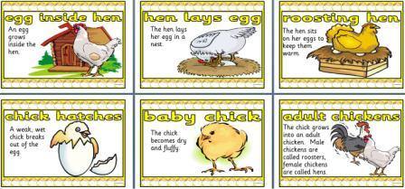

|  |
| --- |
| <html>  <body>  <table border="2">  <tr>  <td><h2 align="center"><font color="black">EGG INSIDE HEN</font color></h2><br>  <p align="center">An egg grows inside hen<br>  <img src="https://th.bing.com/th/id/OIP.NC0EJJfT4Tp90dPUoEfL3wHaJj?w=140&h=180&c=7&r=0&o=5&dpr=1.25&pid=1.7"  width="150" height="150"></p></td>  <td><h2 align="center"><font color="black">HEN LAYS EGGS</font color></h2><br>  <p align="center">The hen lays eggs in a nest<br>  <img src="https://th.bing.com/th/id/OIP.3Xrgxb3rioWOOeIALvRRsgHaGK?w=226&h=188&c=7&r=0&o=5&dpr=1.25&pid=1.7"  width="150" height="150"></p></td>    <td><h2 align="center"><font color="black">ROOSTING HEN</font color></h2><br>  <p align="center">The hen sits on her eggs to kepe them warm<br>  <img src="https://th.bing.com/th/id/OIP.CdZJmg9xANVffOiR68BgxQHaIj?w=150&h=180&c=7&r=0&o=5&dpr=1.25&pid=1.7"  width="150" height="150"></p></td>    </tr>  <tr>  <td><h2 align="center"><font color="black">CHICK HATCHES</font color></h2><BR>  <p align="center">A weak, wet chick breaks out of the egg<br>  <img src="https://th.bing.com/th/id/OIP.vwcI1_nH-Rif7plHIsV5fwHaHa?w=178&h=180&c=7&r=0&o=5&dpr=1.25&pid=1.7"  width="150" height="150"></p></td>    <td><h2 align="center"><font color="black">BABY CHICK</font color></h2><br>  <p align="center">The chick becomes dry and fluffy<br>  <img src="https://th.bing.com/th/id/OIP.iOX5yFus0Yh4cOdFc4U2nwHaFs?w=266&h=205&c=7&r=0&o=5&dpr=1.25&pid=1.7"  width="150" height="150"></p></td>    <td><h2 align="center"><font color="black">ADULT CHICKENS</font color></h2><br>  <p align="center">The chick grows into a adult chicken.<br> Male chickens are called roosters female chickens are called hens<br>  <img src="adultchicken.jpg" width="150" height="150"></p></td> </tr>  </table>  </body>  </html> |
|  |

1. Create some links to various search engines (google, yahoo, etc).

[Search the web with Google!](http://www.google.com/)  
  
[Search the web with Yahoo!](http://www.yahoo.com/)  
  
[Search the web with Bing!](http://www.bing.com/)

|  |
| --- |
| <html>  <body bgcolor="pink">  <ul>  <li> <a href = "https://www.google.co.in/"> <font color="red"> GOOGLE </font> </a> </li> <br>  <li> <a href = "https://www.youtube.com/"> <font color="red"> YOUTUBE </font> </a> </li> <br>  <li> <a href = "https://in.search.yahoo.com/?fr2=inr"> <font color="red"> YAHOO </font> </a> </li> <br>  <li> <a href = "http://www.bing.com"> <font color="red"> BING </font> </a> </li><br>  <li> <a href = "http://www.weather.com"> <font color="red"> TODAY WEATHER</font> </a> </li><br>  </ul>  </body>  </html> |
|  |

1. Display five different images. Skip two lines between each image. Each image should have a title.

|  |
| --- |
| <html>  <body>  <img src="E:\Web designing lab/BTS.jpg" width="200" height="200" alt="BTS" title="BTS" border="2" />  <br>  <br>  <img src="E:\Web designing lab/ATEEZ.jpg" width="200" height="200" alt="ATEEZ" title="ATEEZ" border="2"/>  <br>  <br>  <img src="E:\Web designing lab/STRAY KIDS.jpg" width="200" height="200" aalt="STRAY KIDS" title="STRAY KIDS" border="2" />  <br>  <br>  <img src="E:\Web designing lab/TXT.jpg" width="200" height="200" a alt="TXT" title="TXT" border="2" />  <br>  <br>  <img src="E:\Web designing lab/ENHYPHEN.jpg" width="200" height="200" a src="ENHYPHEN" title="ENHYPHEN" border="2"/>  </body>  </html> |
|  |

1. Display an image that has a border of size 2, a width of 200, and a height of 200.

|  |
| --- |
| <html>  <body>  <img src="E:\SEM4\Web designing lab\img13.jpg" border="2" width="200" height ="200">  </body>  </html> |
|  |

1. Display an image that when clicked will link to a search engine of your choice (should be opened in a new window).

|  |
| --- |
| <html>  <body>  <a href="https://ibighit.com/bts/eng/" target="_blank">  <img src="E:\Web designing lab/BTS.jpg" width="400" height="300" alt="BTS" title="BTS" border="2" />  <p>  CLICK TO VISIT BIGHIT WEBSITE  </p>  <br>  </p>  </body>  </html> |
|  |

1. Create a webpage using image map tag. If click on any logo image, show the information about the company using unordered/ordered list tag. Minimum 5 information for each icon.



|  |
| --- |
| <html>  <body>  <img src="car_logo.jpg" width="400" height="200" alt="Car" usemap="#car_logomap">  <map name="car_logomap">  <area shape="poly" coords="0,0,110,0,110,80,0,80" alt="Benz" a href="https://www.mercedes-benz.co.in/">  <area shape="poly" coords="112,0,186,23,187,85,104,85" alt="Toyota" a href="https://www.toyotabharat.com/">  <area shape="poly" coords="200,0,260,0,260,85,190,90" alt="BMW" href="https://www.bmw.in/en/index.html">  <area shape="poly" coords="265,20,330,20,325,80,264,80" alt="Volkswagon" a href="https://www.volkswagen.co.in/en.html">  <area shape="poly" coords="335,20,380,20,385,80,333,78" alt="Honda" a href="https://www.honda2wheelersindia.com/">  <area shape="poly" coords="15,100,100,100,100,150,20,145" alt="Nissan" a href="https://en.wikipedia.org/wiki/Nissan">  <area shape="poly" coords="115,100,180,90,180,155,112,155" alt="Porsche" a href="https://www.porsche.com/middle-east/_india_/">  <area shape="poly" coords="185,100,250,100,250,140,185,140" alt="Ford" a href="https://www.ford.com/">  <area shape="poly" coords="260,100,330,100,330,140,255,140" alt="Audi" a href="https://www.audi.in/in/web/en.html">  <area shape="poly" coords="340,100,400,100,400,138,335,140" alt="chevrolet" a href="https://www.chevrolet.com/">  </map>  </body>  </html> |
|  |

1. Design an image map for the given images. Info about indian states should be displayed when hover/clicked.

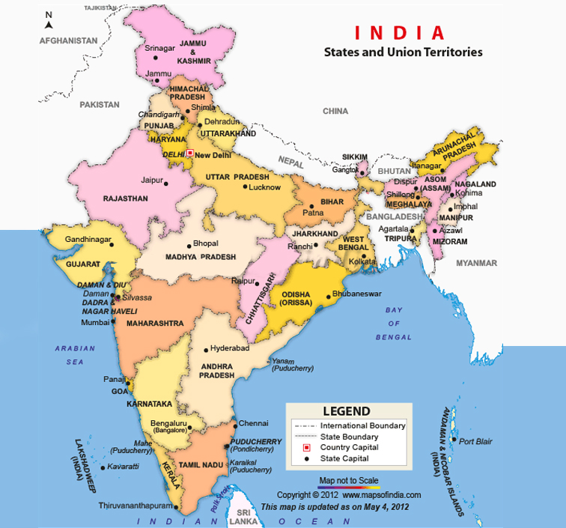

|  |
| --- |
| <html>  <body>  <img src="indian_map.jpg" width="600" height="800" alt="indian_map" usemap="#indian_mapmap">  <map name="indian_mapmap">  <area shape="poly" coords="156,666,184,694,198,787,185,766" alt="Kerala" a href="https://en.wikipedia.org/wiki/Kerala">  <area shape="poly" coords="187,693,262,645,249,761,201,792," alt="Tamilnadu" a href="https://en.wikipedia.org/wiki/Tamil_Nadu%22">  <area shape="poly" coords="137,579,146,583,147,600,141,600" alt="Goa" a href="https://en.wikipedia.org/wiki/Goa">  <area shape="poly" coords="150,583,205,511,217,660,155,670" alt="Karnataka" a href="https://en.wikipedia.org/wiki/Karnataka">  <area shape="poly" coords="207,513,340,495,270,638,195,635" alt="Andra pradesh" a href="https://en.wikipedia.org/wiki/Andhra_Pradesh">  <area shape="poly" coords="125,463,262,428,260,500,140,580" alt="Maharastra" a href="https://en.wikipedia.org/wiki/Maharashtra">  <area shape="poly" coords="255,500,287,371,330,393,283,521" alt="chattisgarh" a href="https://en.wikipedia.org/wiki/Chhattisgarh">  <area shape="poly" coords="281,522,322,400,392,416,337,495" alt="Odisha" a href="https://en.wikipedia.org/wiki/Odisha">  <area shape="poly" coords="49,349,155,383,128,462,62,411" alt="Gujarat" a href="https://en.wikipedia.org/wiki/Gujarat">  <area shape="poly" coords="172,338,298,350,254,424,162,415" alt="Madhay Pradesh" a href="https://www.bing.com/search?q=madhya+pradesh&cvid=7910ede55d3247d2bb12b498546e9b55&aqs=edge.1.69i57j0l8.6570j0j4&FORM=ANAB01&PC=DCTS">  <area shape="poly" coords="317,351,382,,345,366,397,334,400" alt="Jharkhand" a href="http://en.wikipedia.org/wiki/Jharkhand">  <area shape="poly" coords="365,379,400,348,410,403,378,405" alt="West bengal" a href="https://en.wikipedia.org/wiki/West_Bengal">  <area shape="poly" coords="80,274,146,198,214,290,155,377" alt="Rajasthan" a href="https://en.wikipedia.org/wiki/Rajasthan">  <area shape="poly" coords="212,264,215,210,317,283,307,339" alt="Uttra pradesh" a href="https://en.wikipedia.org/wiki/Uttar_Pradesh">  <area shape="poly" coords="320,338,334,288,391,298,371,332" alt="Bihar" a href="https://en.wikipedia.org/wiki/Bihar">  <area shape="poly" coords="187,247,169,208,203,197,204,250" alt="Haryana" a href="http://en.wikipedia.org/wiki/Haryana">  <area shape="poly" coords="220,192,242,174,268,196,255,224" alt="uttrakhand" a href="http://en.wikipedia.org/wiki/Uttarakhand">  <area shape="poly" coords="154,193,175,151,193,184,180,200" alt="Punjab" a href="http://en.wikipedia.org/wiki/Punjab,_India">  <area shape="poly" coords="185,142,210,127,230,157,210,177" alt="Himachal pradesh" a href="http://en.wikipedia.org/wiki/Himachal_Pradesh">  <area shape="poly" coords="173,120,148,22,247,52,239,125" alt="Jammu and kashmir" a href="http://en.wikipedia.org/wiki/Jammu_and_Kashmir_(state)">  <area shape="poly" coords="400,264,458,220,518,206,540,248" alt="Arunachal pradesh" a href="http://en.wikipedia.org/wiki/Arunachal_Pradesh">  <area shape="poly" coords="430,295,430,281,517,245,476,336" alt="Assam" a href="http://en.wikipedia.org/wiki/Assam">  </map>  </body>  </html> |
|  |

1. Design an image map for the given picture and when clicked/moved over, info about that person should be displayed.

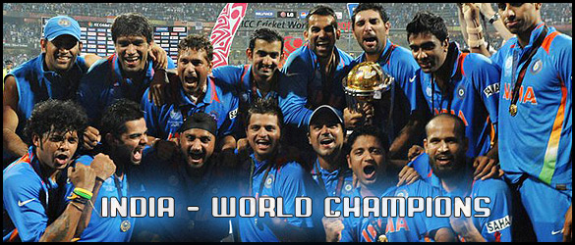

|  |
| --- |
| <html>  <body>  <img src="sports.jpg" usemap="#image-map" width="584" height="538">  <map name="image-map">  <area target="_blank" alt="Dhoni" title="Dhoni" href="https://en.wikipedia.org/wiki/MS_Dhoni" coords="23,70,89,68,85,145,24,153" shape="poly">  <area target="_blank" alt="Patel" title="Patel" href="https://en.wikipedia.org/wiki/Munaf_Patel" coords="100,9,167,16,166,150,102,180" shape="poly">  <area target="_blank" alt="Sachin" title="Sachin" href="https://en.wikipedia.org/wiki/Sachin_Tendulkar" coords="169,81,234,78,231,215,163,221" shape="poly">  <area target="_blank" alt="Gambhir" title="Gambhir" href="https://en.wikipedia.org/wiki/Gautam_Gambhir" coords="218,43,296,60,298,192,238,187" shape="poly">  <area target="_blank" alt="Zaheer " title="Zaheer " href="https://en.wikipedia.org/wiki/Zaheer_Khan" coords="290,26,349,18,346,117,302,125" shape="poly">  <area target="_blank" alt="Yuvraj" title="Yuvraj" href="https://en.wikipedia.org/wiki/Yuvraj_Singh" coords="350,29,405,21,399,111,361,129 " shape="poly">  <area target="_blank" alt="Ashwin" title="Ashwin" href="https://en.wikipedia.org/wiki/Ravichandran_Ashwin" coords="403,71,467,70,467,169,415,171" shape="poly">  <area target="_blank" alt="Nehra" title="Nehra" href="https://en.wikipedia.org/wiki/Ashish_Nehra" coords="489,16,563,18,564,110,494,91" shape="poly">  <area target="_blank" alt="Sreesanth" title="Sreesanth" href="https://en.wikipedia.org/wiki/S._Sreesanth" coords="16,243,91,293,79,370,17,370" shape="poly">  <area target="_blank" alt="Kohli" title="Kohli" href="https://en.wikipedia.org/wiki/Virat_Kohli" coords="105,236,156,279,150,365,97,355" shape="poly">  <area target="_blank" alt="Harbhajan" title="Harbhajan" href="https://en.wikipedia.org/wiki/Harbhajan_Singh" coords="167,270,225,289,228,360,168,370" shape="poly">  <area target="_blank" alt="Raina" title="Raina" href="https://en.wikipedia.org/wiki/Suresh_Raina" coords="225,246,293,243,295,336,236,344" shape="poly">  <area target="_blank" alt="Sehwag" title="Sehwag" href="https://en.wikipedia.org/wiki/Virender_Sehwag" coords="299,254,358,258,339,338,310,337" shape="poly">  <area target="_blank" alt="Chawla" title="Chawla" href="https://en.wikipedia.org/wiki/Piyush_Chawla" coords="355,325,401,314,407,390,357,399" shape="poly">  <area target="_blank" alt="Yusuf" title="Yusuf" href="https://en.wikipedia.org/wiki/Yusuf_Pathan" coords="418,281,473,292,479,371,428,379" shape="poly">  </map>  </body>  </html> |
|  |